Tender Management Site

Contents

1. USE CASE DIAGRAM 5

2.DOMAIN CLASS DIAGRAM 6

6

2. Crud matrix 7

3. *First Cut DCD’s* 8

**1.** **[Add Company]** 8

**2.** **[Advertise Tender]** 8

**3.** **[View Tender Application]** 9

**4.** **[Cancel Tender Application]** 9

**5.** **[Update Tender]** 9

6. Apply tender 10

7.Approve tender 12

9. view tender 14

10. Add user 15

4. FULL USECASE DESCRIPTION 16

1. [**Register Company**] 16

2. [**Advertise Tender**] 17

3. [**View Application**] 18

4. [**Cancel Tender Application**] 18

5. [**Update Tender**] 19

6 **Make tender application** 20

7. **Approve tender** 21

8. **Reward tender** 21

9.**Add user** 22

10.**View tender** 23

5.SEQUENCE DIAGRAMS 23

View Application 24

Cancel Application 24

Advertise Tender 25

Update Tender 26

Add Company 27

**Make tender application** 28

**Approve tender** 30

Reward tender 31

View tender 32

Add client 32

**Detailed sequence diagram** 33

1.View Application 33

2.Cancel Application 34

3.Advertise Tender 34

4.Update Tender 35

5.Apply tender 36

6.Approve tender 37

7. Assign tender 37

8.view tender 38

9.Add User 38

10. Add Company 39

6.Package Diagram 39

View Application 39

Cancel Application 40

Advertise Tender 41

Update Tender 42

Apply tender 43

Approve tender 43

Assign tender 44

View tender 45

Add User 46

1. USE CASE DIAGRAM

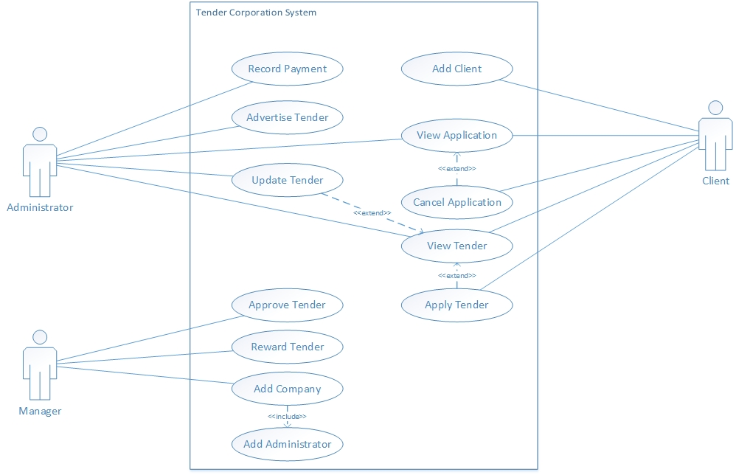

# 2.DOMAIN CLASS DIAGRAM

# D:\IDC30BT\DomainClassDiagram.jpg

1. Crud matrix

|  |  |  |  |  |  |  |  |
| --- | --- | --- | --- | --- | --- | --- | --- |
| Use case vs. domain class | user | company | category | tender | application | Payment | AppDoc |
| Add Company | *C* | *C* |  |  |  |  |  |
| Advertise tender |  |  | *R* | *C* |  |  | C |
| View application | *R* |  |  | R | *R* |  | *R* |
| Cancel tender  application | R |  |  |  | *U* |  | *R* |
| Update tender  Details |  |  | *R* | *U* |  |  |  |
| Add admin | *C* | *R* |  |  |  |  |  |
| Record  Payment |  |  |  |  | *R* | *C* |  |
| Apply Tender | *R* |  |  | *R* | *C* |  |  |
| Approve  Tender |  |  |  | *U* |  |  |  |
| Reward  tender |  |  |  |  | *U* |  |  |
| View tender |  |  | *R* | *R+* |  |  |  |
| Add client | *C* |  |  |  |  |  |  |

1. *First Cut DCD’s*

|  |
| --- |
| Use Cases |
| * ADD COMPANY * ADD ADMINISTRATOR * ADD CLIENT * ADVERTISE TENDER * VIEW TENDER * MAKE TENDER APPLICATION * VIEW APPLICATION * MAKE PAYMENT * APPROVE TENDER * ASSIGN TENDER * UPDATE TENDER * CANCEL TENDER APPLICATION |

1. **[Add Company]**

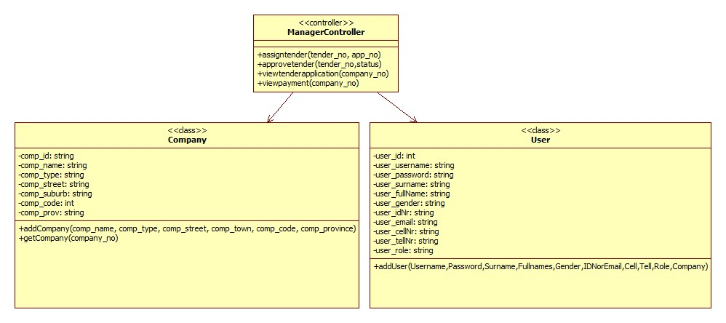

1. **[Advertise Tender]**

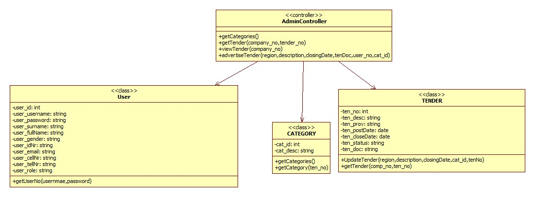

1. **[View Tender Application]**

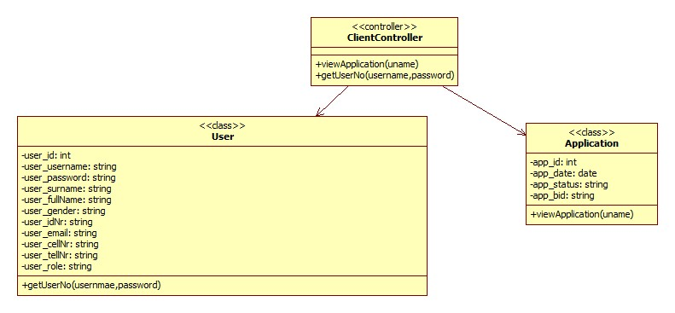

1. **[Cancel Tender Application]**

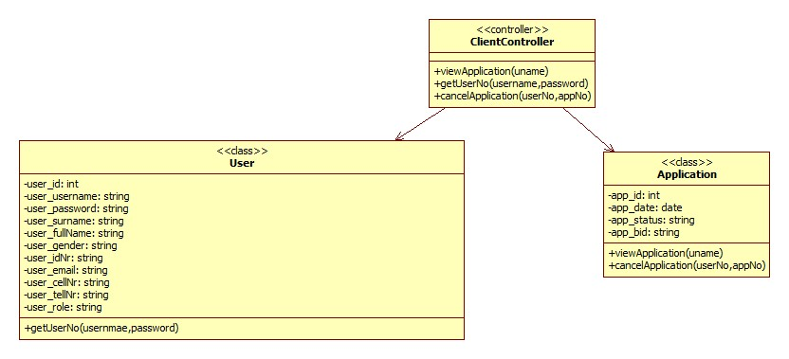

1. **[Update Tender]**

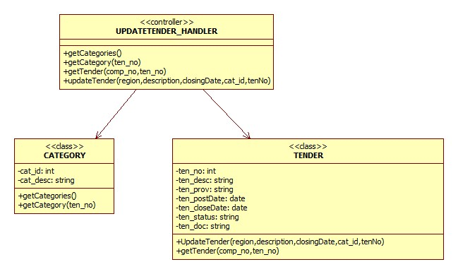

1. Apply tender

|  |
| --- |
| <<controller>>  ClientController |
|  |
|  |

|  |
| --- |
| Client |
| -rUserNo:int  -rUsername:String  -rPassword:String  -rSurname:String  -rFullnames:String  -rGender:String  -rIDNo:String  -rEmali:String  -rCell:int  -rTell;int  -rRole:String  -rCompany:String |
|  |

|  |
| --- |
| Tender |
| -ten_no:int  -ten_region:String  -ten_desc:String  -ten_postDate:Date  -ten_closingDate:Date  -ten_Status:String  -ten_doc:String  -ten_view:int  -ten_cat:String |
|  |

|  |
| --- |
| Application |
| -appNo:int  -appDate:Date  -appStatus:String  -appBid:String  -appAmount:double  -tenDesc:String  -username:String |
|  |

# 7.Approve tender

|  |
| --- |
| <<view >>  ApproveTender |
|  |
|  |

|  |
| --- |
| <<controller>>  ManagerController |
|  |
|  |

|  |
| --- |
| <<Model>>  Manager |
| -rUserNo:int  -rUsername:String  -rPassword:String  -rSurname:String  -rFullnames:String  -rGender:String  -rIDNo:String  -rEmali:String  -rCell:int  -rTell:int  -rRole:String  -rCompany:String |
|  |

|  |
| --- |
| <<Model>>  Tender |
| -ten_no:int  -ten_region:String  -ten_desc:String  -ten_postDate:date  -ten_closingDate:date  -ten_Status:String  -ten_doc:String  -ten_view:int  -ten_cat :String |
|  |

8. Assign tender

|  |
| --- |
| <<view >>  AssignTender |
|  |
|  |

|  |
| --- |
| <<controller>>  ManagerContoller |
|  |
|  |

|  |
| --- |
| <<Model>>  Manager |
| -rUserNo:String  -rUsername:String  -rPassword:String  -rSurname:String  -rFullnames:String  -rGender:String  -rIDNo:String  -rEmail:String  -rCell:int  -rTell:int  -rRole:String  -rCompany:String |
|  |

|  |
| --- |
| <<Model>>  Tender |
| -ten_no:int  -ten_region:String  -ten_desc:String  -ten_postDate:date  -ten_closingDate:date  -ten_Status:String  -ten_doc:String  -ten_view:int  -ten_cat:String |
|  |

# 9. view tender

|  |
| --- |
| <<view >>  ViewTender |
|  |
|  |

|  |
| --- |
| <<controller>>  ClientController |
|  |
|  |

|  |
| --- |
| <<Model>>  Client |
| -rUserNo:String  -rUsername:String  -rPassword:String  -rSurname:String  -rFullnames:String  -rGender:String  -rIDNo:String  -rEmail:String  -rCell:int  -rTell:int  -rRole:String  -rCompany:String |
|  |

|  |
| --- |
| <<Model>>  Tender |
| -ten_no:int  -ten_region:String  -ten_desc:String  -ten_postDate:date  -ten_closingDate:date  -ten_Status:String  -ten_doc:String  -ten_view:int  -ten_cat:String |
|  |

# 10. Add user

|  |
| --- |
| <<view >>  Profile |
|  |
|  |

|  |
| --- |
| <<controller>>  IndexController |
|  |
|  |

|  |
| --- |
| User |
| -rUserNo:String  -rUsername:String  -rPassword:String  -rSurname:String  -rFullnames:String  -rGender:String  -rIDNo:String  -rEmail:String  -rCell:int  -rTell:int  -rRole:String  -rCompany:String |
|  |
|  |

1. FULL USECASE DESCRIPTION

|  |
| --- |
| Use Cases |
| * ADD COMPANY * ADD ADMINISTRATOR * ADD CLIENT * ADVERTISE TENDER * VIEW TENDER * MAKE TENDER APPLICATION * VIEW APPLICATION * MAKE PAYMENT * APPROVE TENDER * ASSIGN TENDER * UPDATE TENDER * CANCEL TENDER APPLICATION |

1. [**Register Company**]

|  |  |  |
| --- | --- | --- |
| Use case name: | Register a company | |
| Scenario: | Register a company for tenders. | |
| Triggering event: | Company has tender(s) to offer | |
| Brief description | A company has available tenders to be offered | |
| Actor(s): | Manager. | |
| Related use cases: | Add Admin. | |
| Preconditions: | Company number must exist. | |
| Post conditions: | Company record must be created and saved.  Admin responsible for the company must be saved. | |
| Flow of activities: | **Actor** | **System** |
| 1. Manager enters company details   2.Manager enters admin details  3.Manager confirm registration | * 1. System creates company record and saves on the DB.   2. System prompt for Admin details   3. System creates an Admin record and saves on the DB   4. System prompt for confirmation |
| Exception conditions: | * 1. Basic company data are incomplete.   2. Basic admin data are incomplete. | |

2. [**Advertise Tender**]

|  |  |  |
| --- | --- | --- |
| Use case name: | Advertise tender | |
| Scenario: | An Admin post a tender. | |
| Triggering event: | An Admin wants to notify companies for available tenders. | |
| Brief description | Admin add tender basic information and uploads files for detailed information about a particular tender. | |
| Actor(s): | Administrator. | |
| Related use cases: | None. | |
| Preconditions: | Tender info must not exist on the DB.  Document explaining the type of tender to be advertised must exist. | |
| Post conditions: | Tender advert must be posted.  Advert information must be validated. | |
| Flow of activities: | **Actor** | **System** |
| 1. Administrator enters basic tender details and upload necessary files. | 1.1 The system saves the information.  1.2 System display the tender. |
| Exception conditions: | * 1. Closing date isn’t valid. | |

3. [**View Application**]

|  |  |  |
| --- | --- | --- |
| Use case name: | View Application | |
| Scenario: | A Client views an application. | |
| Triggering event: | Tender application request. | |
| Brief description | A Client enters a category of tender with which s/he made applications for, the system retrieves and display all applications for that particular category | |
| Actor(s): | Client. | |
| Related use cases: | Cancel Application. | |
| Preconditions: | Application must have been made successfully. | |
| Post conditions: |  | |
| Flow of activities: | **Actor** | **System** |
| 1. Client select category of which s/he wants to view tenders for. | 1.1 The system retrieves and display all tenders of that category. |
| Exception conditions: | * 1. No application(s) found. | |

4. [**Cancel Tender Application**]

|  |  |  |
| --- | --- | --- |
| Use case name: | Cancel Tender Application | |
| Scenario: | Client views and cancel application. | |
| Triggering event: | Cancel tender application request. | |
| Brief description | A Client enters a category of tender with which s/he made applications for, the system retrieves and display all applications for that particular category. The client has an option to cancel a particular application | |
| Actor(s): | Client. | |
| Related use cases: | Cancel Tender Application. | |
| Preconditions: | Application must have been made successfully.  Application should not be **rewarded**. | |
| Post conditions: | Application should be marked as cancelled. | |
| Flow of activities: | **Actor** | **System** |
| 1. Client select category of which s/he wants to view tenders for. 2. Client select to cancel application. 3. Client confirm cancellation | * 1. The system retrieves and display all tenders of that category.   2.1 The system prompt for confirmation  3.1 The system deletes the application record on the DB |
| Exception conditions: | * 1. Could not cancel application. | |

5. [**Update Tender**]

|  |  |  |
| --- | --- | --- |
| Use case name: | Update tender | |
| Scenario: | An Admin update a tender. | |
| Triggering event: | Tender updates request. | |
| Brief description | Admin select to update tender and enters the new tender basic information. | |
| Actor(s): | Administrator. | |
| Related use cases: | View Tender. | |
| Preconditions: | Tender info must exist on the DB.. | |
| Post conditions: | Tender advert details must be changed.  Advert information must be validated. | |
| Flow of activities: | **Actor** | **System** |
| 1. Administrator select region to view tenders posted. 2. Administrator select to update tender and enters new tender basic info. 3. Administrator confirm changes | 1.1 System display the tender.  2.1 The system prompt for confirmation  3.1 The system updates the record and display the newly updates record. |
| Exception conditions: | * 1. Can’t update tender. | |

6 **Make tender application**

|  |  |  |
| --- | --- | --- |
| Use case name: | Make tender application. | |
| Scenario: | A client wants to apply for a tender. | |
| Triggering event: | Notification for a new tender to be applied for. | |
| Brief description | Client applies for a new tender online by filling all the necessary information needed. | |
| Actor(s): | Client, Company representative. | |
| Related use cases: | None. | |
| Preconditions: | Client must register on our website.  Client login details must exist in the database. | |
| Post conditions: | Client application details must be captured in the database. | |
| Flow of activities: | **Actor** | **System** |
| 1 Client clicks on Apply for tender on the menu.  2 Clients adds application details and clicks on apply. | 1.1 System navigates the user to the page where they should add their application details.  2.1 System saves the information and displays a message of confirmation to the user. |
| Exception conditions: | Tender Documents not provided. | |

7. **Approve tender**

|  |  |  |
| --- | --- | --- |
| Use case name: | Approve tender | |
| Scenario: | Approve a tender application made. | |
| Triggering event: | Applications made by clients. | |
| Brief description | Manager wants to approve a certain tender that has been applied for. | |
| Actor(s): | Manager. | |
| Related use cases: | None. | |
| Preconditions: | The tender application must be complete.  Tender number must exist.  Company number must exist. | |
| Post conditions: | Tender status changes to approved. | |
| Flow of activities: | **Actor** | **System** |
| 1. Manager clicks on Applied tenders on the menu.  2. Manager clicks on “approve tender” icon next to any certain tender they want to approve. | 1.1System navigates the Manager to all the tenders that has been applied for.  2.1 System saves and changes the tender status to “approved” in the database. |
| Exception conditions: | Basic company info is incomplete on application. | |

8. **Reward tender**

|  |  |  |
| --- | --- | --- |
| Use case name: | Reward tender | |
| Scenario: | A tender must be rewarded to the relevant client/company. | |
| Triggering event: | Applications made for the tender. | |
| Brief description | Manager rewards a tender to a client which qualifies to have it. | |
| Actor(s): | Manager. | |
| Related use cases: | None. | |
| Preconditions: | The tender must be approved. | |
| Post conditions: | Clients must be notified to start working on the tender | |
| Flow of activities: | **Actor** | **System** |
| 1. Manager clicks on Approved tenders on the menu.  2. Manager clicks on “Reward tender” icon next to any certain tender they want to Reward. | 1.1System navigates the Manager to all the tenders that has been approved.  2.1 System saves and changes the tender status to “Rewarded” in the database. |
| Exception conditions: | Tender status is not “Approved”. | |

9.**Add user**

|  |  |  |
| --- | --- | --- |
| Use case name: | Add client | |
| Scenario: | A clients wants to add their details on the system so they can be able to exist on the database and login. | |
| Triggering event: | Request for access to the system. | |
| Brief description | Admin enters client details so the client can be registered to access the system. | |
| Actor(s): | Admin. | |
| Related use cases: | None. | |
| Preconditions: | Client must not exist on our system. | |
| Post conditions: | Client details must be captured to the database.  A message to confirm that the client details are successfully added must be displayed. | |
| Flow of activities: | **Actor** | **System** |
| 1. Admin clicks on Register User on the menu.  2. Admin adds client details and clicks on Register. | 1.1 System navigates the admin to the page where they should add the registration details of the user.  2.1 System saves the information and displays a message of confirmation to the user. |
| Exception conditions: | User exists in the database. | |

10.**View tender**

|  |  |  |
| --- | --- | --- |
| Use case name: | View tender. | |
| Scenario: | User wants to view an advertised tender. | |
| Triggering event: | Tender application. | |
| Brief description | User wants to view a tender that has been advertised on our system. | |
| Actor(s): | Admin, Client. | |
| Related use cases: | None. | |
| Preconditions: | Tender must be posted. | |
| Post conditions: | Tender details must be found. | |
| Flow of activities: | **Actor** | **System** |
| 1. User clicks “Tenders” on the menu. | 1. 1 System navigates the user to the page where there are open tenders. |
| Exception conditions: | Tender does not exist. | |

# 5.SEQUENCE DIAGRAMS

SSD

View Application

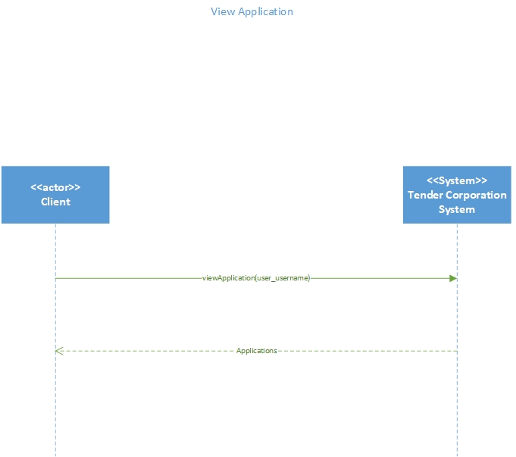

Cancel Application

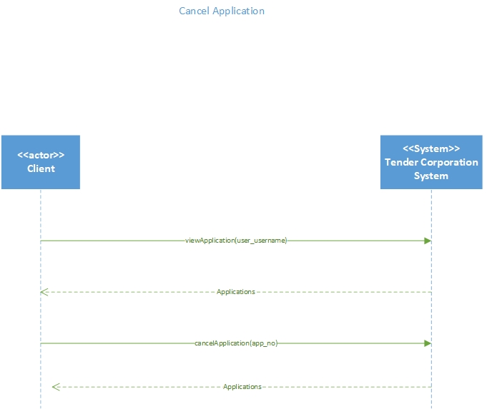

Advertise Tender

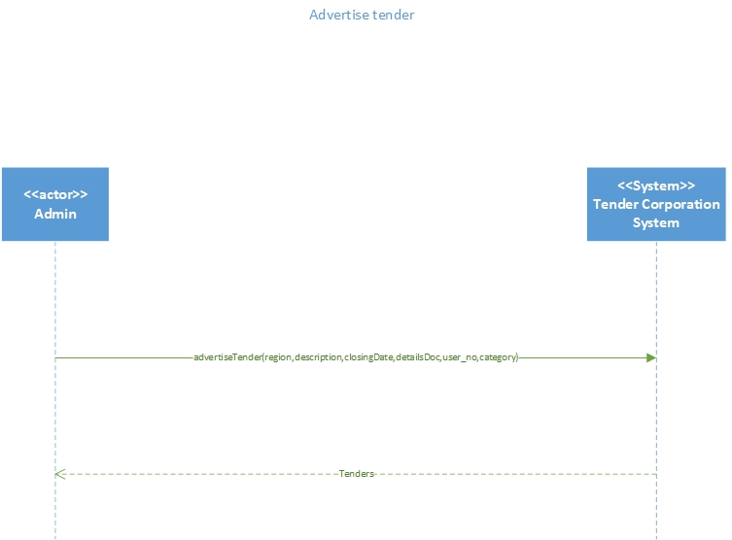

Update Tender

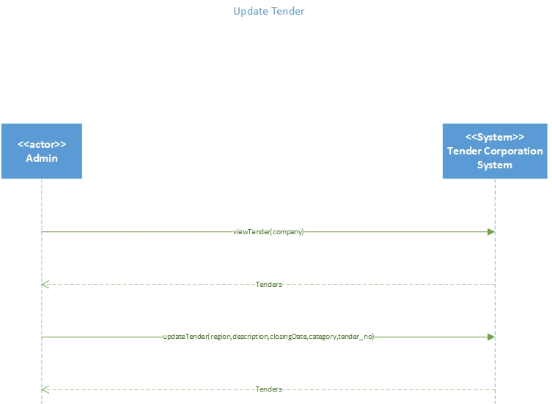

Add Company

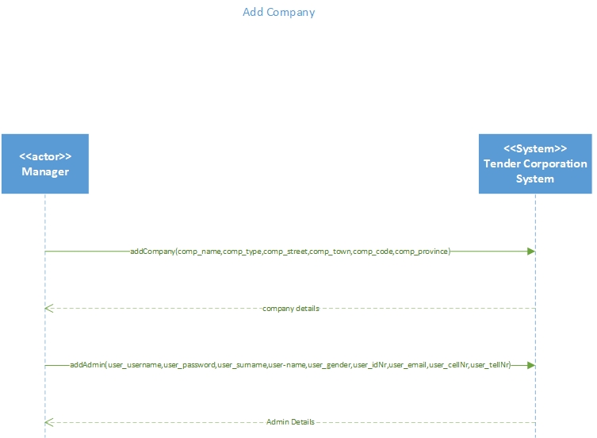

## **Make tender application**

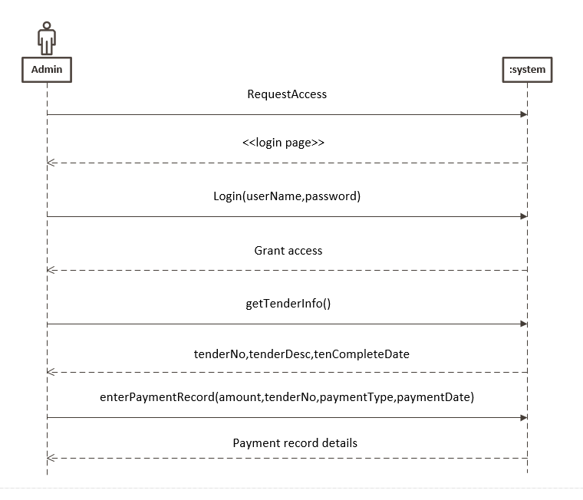

## **Approve tender**

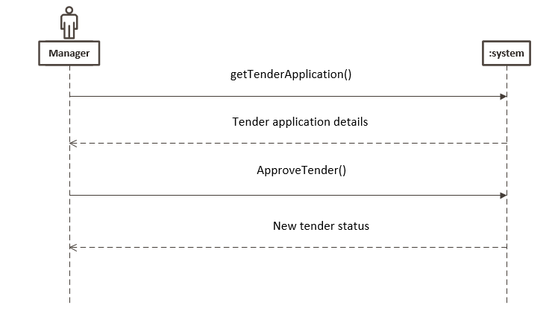

## Reward tender

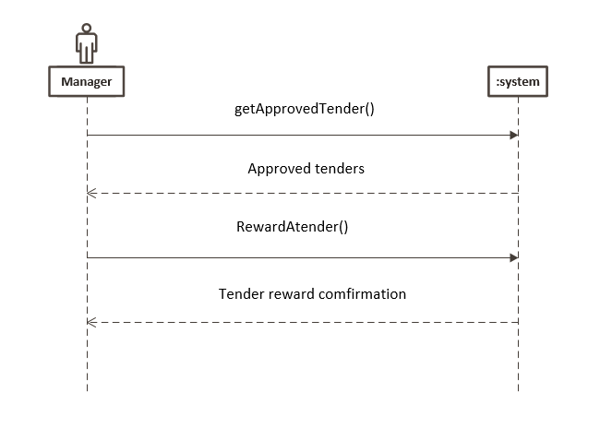

## View tender

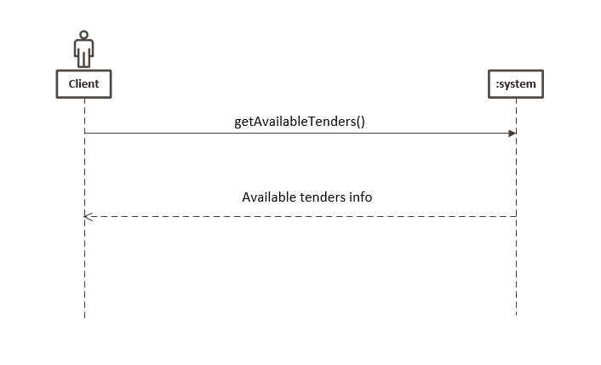

Add client

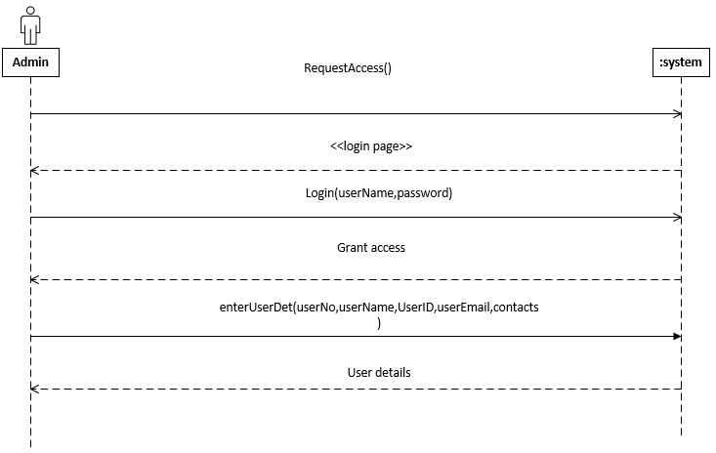

# **Detailed sequence diagram**

## 1.View Application

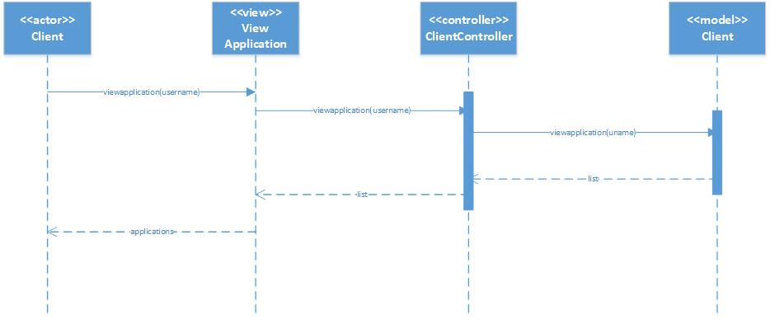

## 2.Cancel Application

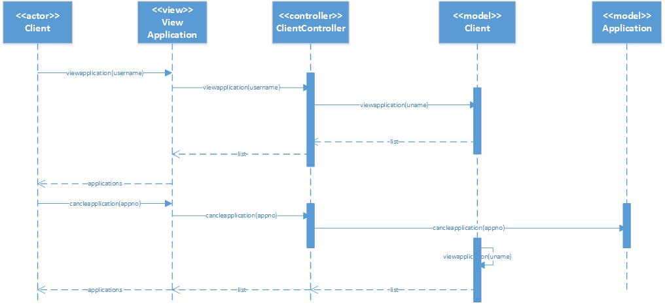

## 3.Advertise Tender

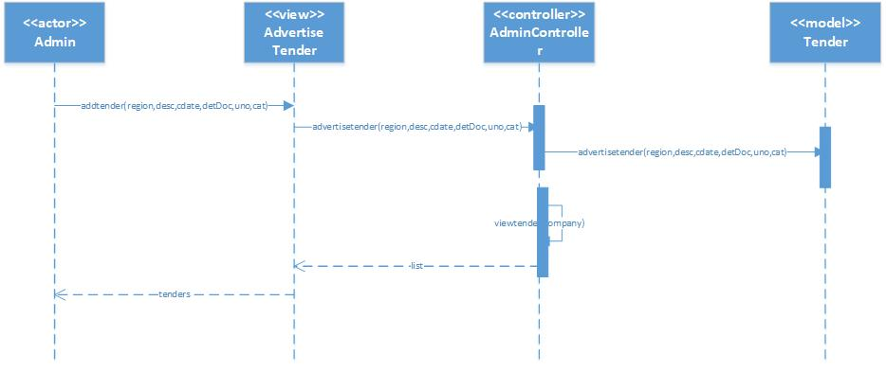

## 4.Update Tender

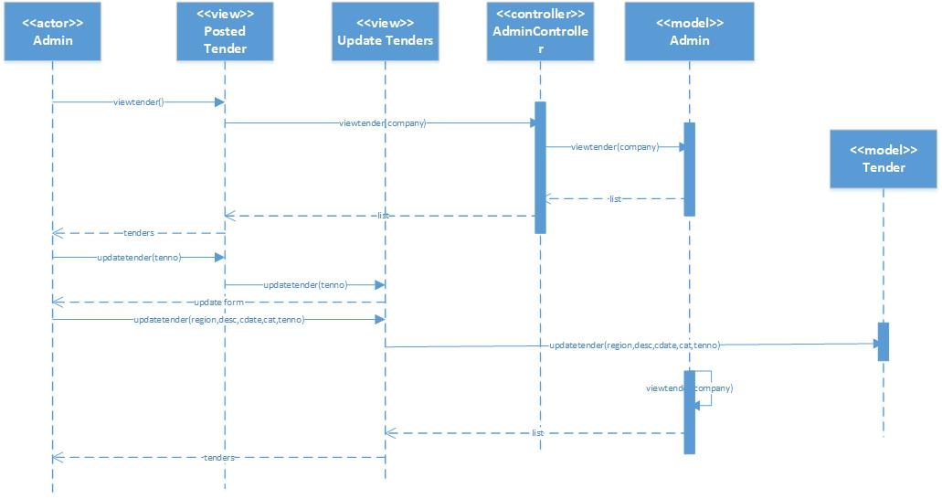

## 5.Apply tender

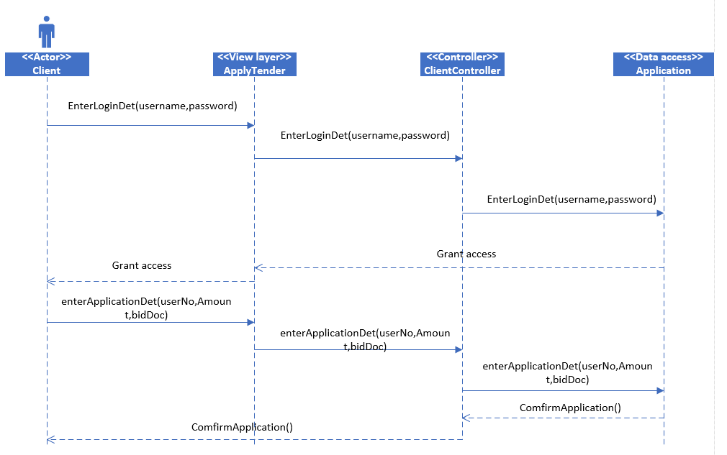

## 6.Approve tender

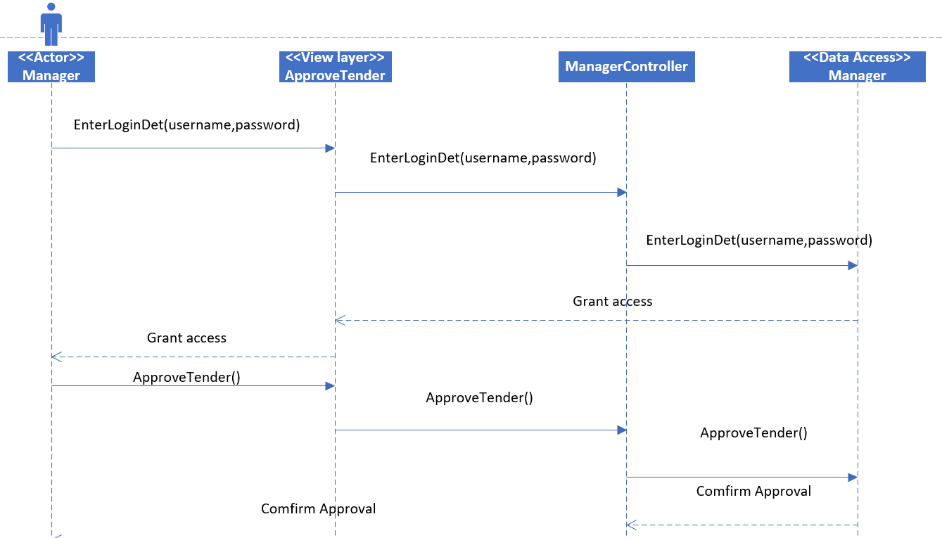

## 7. Assign tender

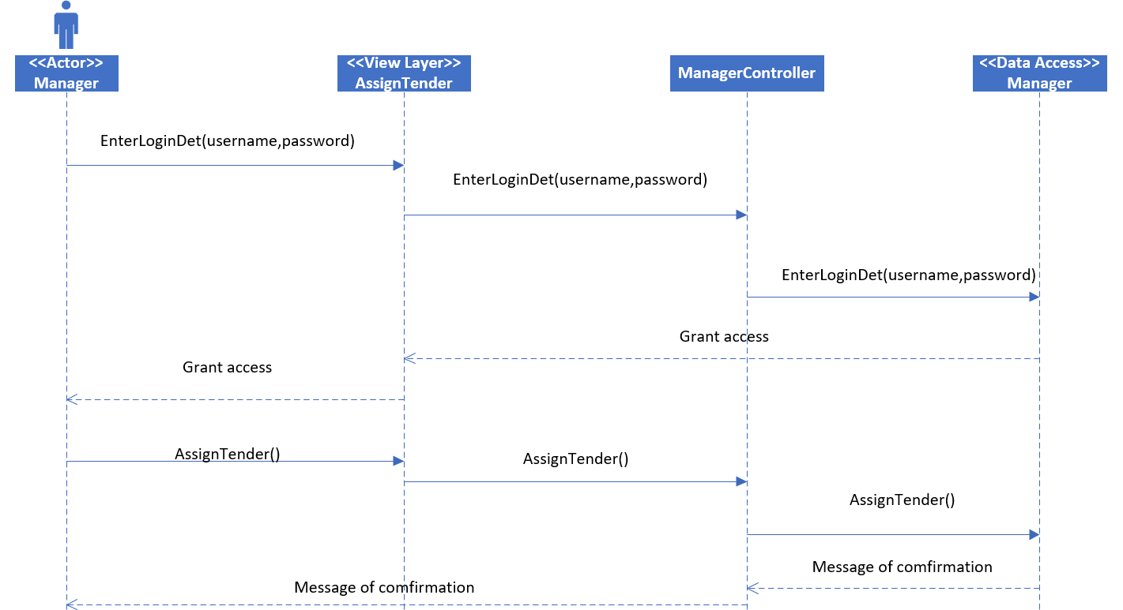

## 8.view tender

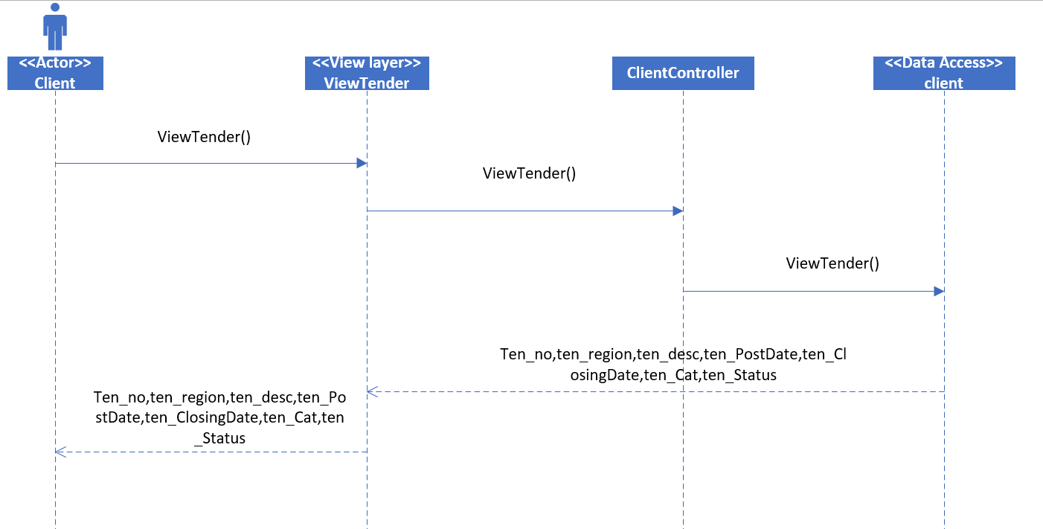

## 9.Add User

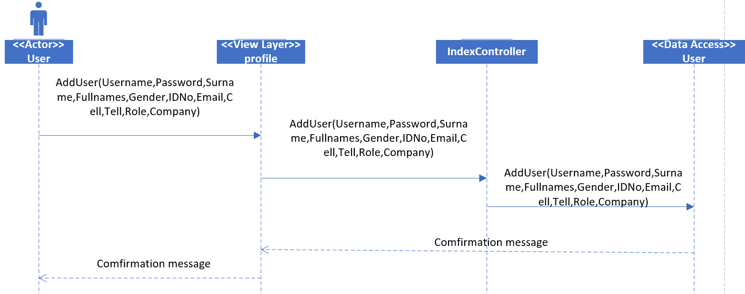

## 10. Add Company

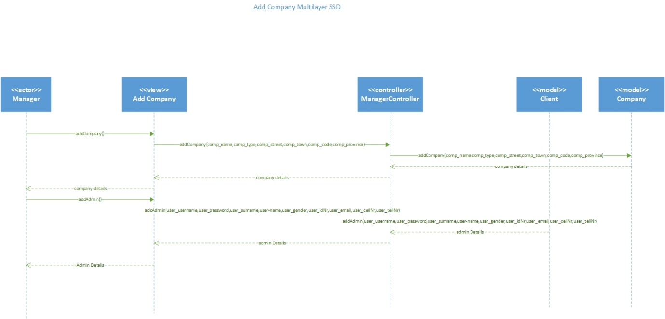

# 6.Package Diagram

## View Application

View

View application

Controller

ClientController

Model

Client

## Cancel Application

View

View application

Controller

ClientController

Model

Client

Application

## Advertise Tender

View

Advertise Tender

Controller

AdminController

Model

Tender

## Update Tender

View

Posted Tenders

Update Tenders

Controller

AdminController

Model

Tender

Admin

## Apply tender

|  |
| --- |
| View layer |

applyTender

|  |
| --- |
| Domain layer |

ClientController

Client

|  |
| --- |
| Data access |

Application

## 

## Approve tender

|  |
| --- |
| View layer |

approveTender

|  |
| --- |
| Domain layer |

ManagerController

manager

|  |
| --- |
| Data access layer |

Manager

## Assign tender

|  |
| --- |
| View layer |

AssignTender

|  |
| --- |
| Domain layer |

|  |
| --- |
| Data access layer |

Manager

## View tender

|  |
| --- |
| View layer |

viewTender

|  |
| --- |
| Domain layer |

client

ClientController

|  |
| --- |
| Data access layer |

client

## Add User

|  |
| --- |
| View layer |

Profile

|  |
| --- |
| Domain layer |

ClientController

Admin

Client

|  |
| --- |
| Data access layer |

User